Subnetting (Solved Problem 2)



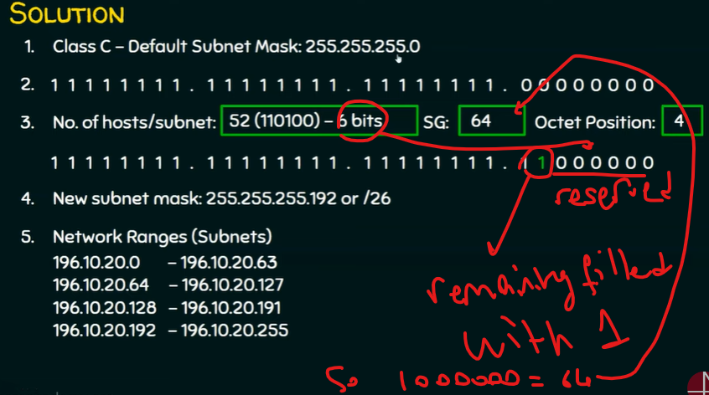

Minimal waste of IP addresses